TWO OUT OF THREE SHOWERS FOR FREE

Adam, Fjaestad, SoletAer AB, Box 112, 671 23 Arvika, Sweden;
Helene, Persson, SoletAer AB, Box 112, 671 23 Arvika, Sweden;
Andreas, Holmén, SoletAer AB, Box 112, 671 23 Arvika, Sweden;

Abstract: There are about 277 000 single-family houses in Sweden which are heated by direct acting electric heaters. In these houses it is very common to install an air-to-air heat pump in order to reduce the electricity use. However, this type of heat pump does not heat the domestic hot water. This paper presents a newly developed solar air heat pump designed for energy efficient production of domestic hot water. In this heat-pump solution solar heating is integrated into the refrigerant circuit. The way the application is designed will decrease the need for defrosting of the system which increases its water heating efficiency. The solar air heat pump also allows for different operating modes depending on operating conditions with the intention to utilize renewable energy sources as much as possible.

Key Words: heat pumps, solar energy, efficiency, defrosting, evaporation

1 INTRODUCTION

This paper deals with the subject of energy efficient preparation of domestic hot water by combining solar technology and heat pump technology. How this combination leads to a reduced need for defrosting and how it affects system efficiency will be shown. The application combines solar technology with heat pump technology in a new way.

- MARKET CONDITIONS

There is an increasing need for energy efficient solutions today. Within the European Union we are working towards the “20-20-20” targets with the key objectives to:

- Reduce greenhouse gas emissions by 20%, from 1990 levels.
- Increase the share of energy produced by renewable resources to 20%.
- Improve energy efficiency by 20%.

(European Commission, 2014)

In 2013 the European commission adopted a regulation regarding energy labeling of water heaters and storage tanks, ENER EuP lot 2, (Swedish Energy Agency, 2013). This will result in banning of energy inefficient technology for water heating. This is advantageous for solar and heat pump technology.

Energy efficiency is important not only from a social point of view but also from the private home owner’s point of view. For those living in homes with direct electrical heating energy costs are substantial and these households become very vulnerable to fluctuations in energy prices. There are already many options on the market for making space heating more energy efficient but when it comes to heating water, the options are often expensive and complex.
In Sweden, domestic hot water requires approximately 20% of the total energy consumption in an average Swedish household. Both energy consumption and energy prices are increasing.

With this background and these identified needs SoletAer, a solar heat pump designed for preparing domestic hot water in single-family houses that are heated by direct electricity has been developed.

According to EU directive 2007/742/EC (Commission, 2007) air/water heat pumps with a Seasonal Performance Factor of at least 2,6 are considered renewable energy sources. SoletAer has a SPF of at least 3,0 which means this application could be an important instrument in reaching the “20-20-20” target. Normally the annual amount of energy used for domestic water heating in an average Swedish family is 3000-7000kWh. In Sweden there are approximately 277 000 single-family houses (Swedish Energy Agency, 2012) producing domestic hot water with electrical boilers. If all these homes would apply an application with an SPF of 3,0, this would amount to energy savings of 0,4-1,0TWh, equivalent to approximately 200 – 460 kton CO₂ (European average electricity production mix).

In a report by VHK for the European Commission (Kemna, van Elburg, Li, van Holsteijn, Denison-Pender, & Corso, 2007) an estimation by BRG Consult showed that there were approximately 51 million electric storage water heaters in the EU. If 4% of them would apply a renewable energy source application such as SoletAer they would generate annual savings of 7.7 TWh, which is more than an average Swedish nuclear reactor produces in one year.

- PRODUCT DESCRIPTION

The developed product SoletAer combines solar technology and heat pump technology in order to make tap water heating more energy efficient. It is mounted on the facade of a house and is connected to the existing electric water heater, Figure 1.

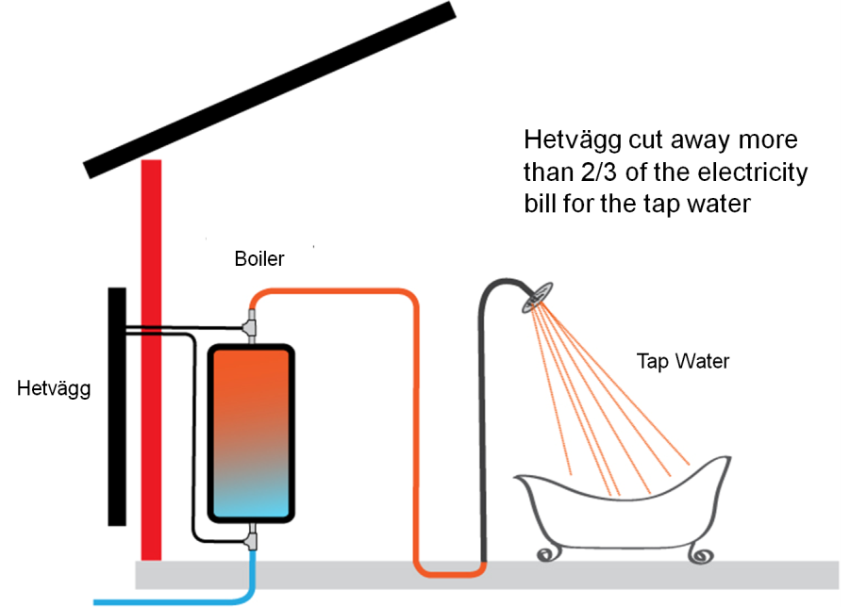
SoletAer

Figure 1. Diagram of the basic principle behind SoletAer.
The two subsystems working together in SoletAer are a thermosiphon loop and an air-to-water heat pump. In this application the thermosiphon is a closed refrigerant circuit where natural circulation occurs as a result of absorbed solar energy. This energy is collected by a solar panel with laser welded copper tubes containing a refrigerant that transfers heat to the tap water. The air-to-water heat pump operates only when the thermosiphon loop has been given a chance to heat the water but failed i.e. when the solar contribution is insufficient during winter/night. During heat pump operation any solar contribution is utilized to improve the evaporation temperature, a result of integrating part of the evaporator with the solar panel. The contribution from the sun varies throughout the year which means that during certain periods SoletAer will be able to heat the water solely with energy from the sun. During much of the year SoletAer works similar to a solar air-source heat pump water heater (SAS-HPWH) which, in a performance study, shown in Figure 2 (Xu, Zhang, & Deng, 2006), was shown to be more energy efficient than both conventional air source heat pumps (AS-HPWH) and electric water heaters (EWH). The comparison shows reported monthly averaged operating performances of conventional systems (EWH, TSWH - Thermosiphon Solar Water Heater & AS-HPWH) under Taiwan conditions and simulated monthly averaged conditions for SAS-HPWH under Nanjing conditions. It should be noted that both these seasonal average temperatures are significantly higher than in Sweden, especially during winter.

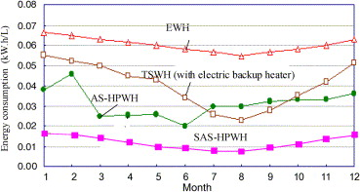

Figure 2. Monthly averaged energy consumption per liter hot water (55 °C) for various water heaters.

In the comparison above there is also a thermosiphon solar water heater (TSWH) which is one of the operational modes used in SoletAer with the exception that it does not include an electric backup heater. This principle is only active when there is adequate solar irradiation combined with warm temperatures i.e. during sunny summer days. The only electricity needed in the SoletAer TSWH case is 2W for the circulating pump, this compared to the EWH mode which according to the graph above uses approximately 55-60W during summer months. Knowing this there is potential that SoletAer could be even more energy efficient than the SAS-HPWH because there is no heat pump operation, instead TSWH is used, without electric backup heater. Figure 3 shows the simulated performance of the SAS-HPWH. During summer months COP for SoletAer should be even better thanks to the integrated thermosiphon loop.
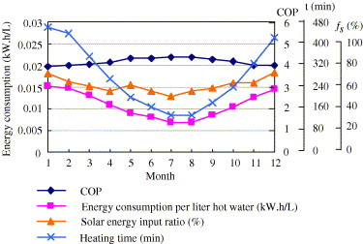
Figure 3. Simulated monthly averaged operating performance of the SAS-HPWH.
The study also showed that the SAS-HPWH was spared from a lot of the commonly encountered problems with evaporator frosting (Xu, Zhang, & Deng, 2006). Less energy for defrosting results in better total system efficiency. This is also the case for SoletAer. This in addition to the TSWH-operation instead of SHP-operation indicates it might be possible to save even more energy with this system design, during the same operating conditions. SoletAer also differs from SAS-HPWH in the fact that there is a fan in the application that draws the air through the battery during heat pump operation. SAS-HPWH relies on natural convection between the air and the spiral-finned tubes of its collector. Figure 4 below shows the different operational modes of different DHW producing systems.

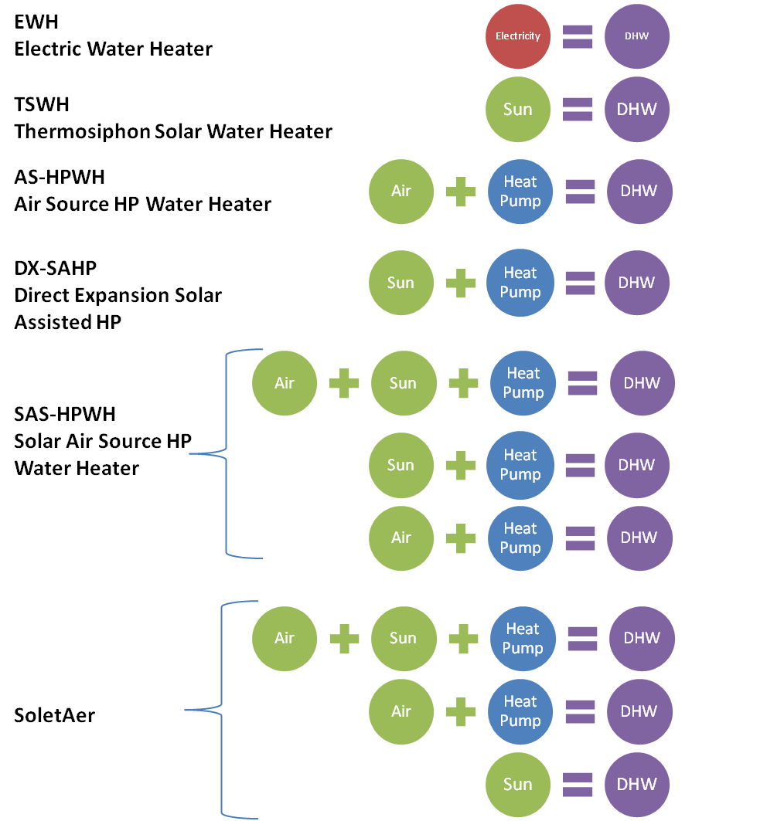
Figure 4. Operational modes of different DHW producing applications.

A normal sized water heater in Sweden has a volume of 185 liters and a built in electrical heater with a heating capacity of 1 kW. With this setup it would take about 8-10 hrs to go from 10°C to 45°C average temperature in the boiler. 1 kW heating capacity and 185 liters volume is more than enough to cope with tap pattern L (EN 16147:2011), even if the insulation of the boiler is poor. If a well insulated tank with the volume 300 liters is used instead, 1 kW is enough to cope with tap pattern XL (EN16147:2011). Heat pump capacity of SoletAer is approximately 1 kW at -7°C and 1,5kW at +7°C. Solar irradiation gives approximately 1kW/m² during clear weather.

- COP REDUCTION DUE TO DEFROSTING

Frost build-up can be a big problem for heat pumps working under cold and humid conditions. In Sweden it is common with a relative humidity of > 75% combined with temperatures around 0°C.

Frost build-up occurs in three stages in ASHP's (Guo, Chen, Wang, & Chen, 2008), in the first stage the heat exchanger performs slightly better than without frost but as the frost layer increase in the second and third phase of the frost build-up the air-flow decreases and the resistance between the moist air and the heat exchanger’s cold surface increases.

As the air channels clog the evaporation pressure and the COP of the heat pump drop. In a typical ASHP it is necessary to defrost more often than once every 45 minutes in order to run with a justifiable COP.

- FROST PROPERTIES SOLETAER VS TYPICAL ASHP

A typical ASHP with a nominal heat capacity of 8,0 kW may have a tube and fin arrangement with a front area of 0,3 m² and multiple tube rows in the air flow direction. This design enables a compact unit, still with a relatively large heat exchange surface rendering a good COP. One of the down sides of this setup though is when the ambient temperature goes below the temperature then ice start to form. Typically the ice builds up at the tip of the fins that meet the incoming air. The front area in combination with the air flow and the amount of water in the air exceeding the saturated level of the air leaving the evaporator determines the interval between defrosts needed.

The front area of the evaporating coil of SoletAer with its inclined positioning is comparable with the front area of an evaporating coil of ASHP’s with 10 times the heating capacity of SoletAer, such as the above described, Figure 5. To acquire 10 times a given heating capacity a greater volume of air is required to pass through the evaporating coil and more air will result in more precipitated moist which contributes to a more rapid build-up of frost.

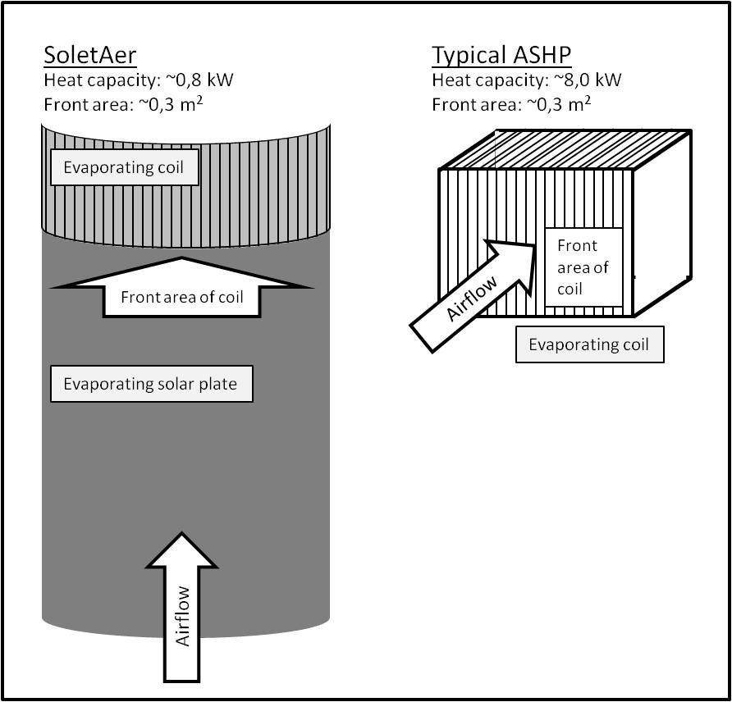
Figure 5. Example of typical ASHP compared to SoletAer.

The ice build-up in SoletAer can be described as follows: Firstly the air passes through a narrow channel, between the solar plate (which also acts as an evaporating surface) and the front window. In doing so a certain amount of moist precipitates on to said plate where frost starts to build up. The air then reaches the evaporating coil, which in the case of SoletAer is a one row inclined finned heat exchanger; the cooling capacity is mostly taken out in the lower part of the coil where frost starts to build up as the air (containing less moisture since it has passed the evaporating solar plate) passes through. As time elapse the frost accumulates until just a small gap remains through which air can pass. As long as air keeps passing the evaporating solar plate the evaporating temperature does not drastically drop. This makes it possible to run SoletAer for longer periods of time under conditions when regular heat pumps have to defrost with tight intervals.

Another factor that keeps the defrosting intervals longer apart for SoletAer is the optional defrosting sequences; ventilation defrost and solar defrost. If the accumulator tank is filled with hot water the heat pump will come to a halt. If frost then has built up on the evaporating surfaces and the ambient temperature is above 0°C the fan is started and the frost will start to melt off. If the heat pump comes to a halt and the sun is shining the frost will melt off without any added power.

When a defrosting cycle is initiated the evaporating solar plate quickly reaches a temperature above 0°C and the ice closest to the plate starts to melt, this results in chunks of ice falling from the solar plate reducing the energy needed to defrost.
- PERFORMED TEST

To verify the claimed defrosting properties of SoletAer some tests has been performed, in Figure 6, the evaporating temperature and the inlet air temperature is shown for a twelve hour test run. As shown in the graph the air temperature remained around 2 °C during the test. The average relative humidity in Arvika during this test was 94,8% (Swedish University of Agricultural Sciences, 2014).

Figure 6. 12 hour operation of SoletAer in humid conditions, with A2W60.

After twelve hours operation, Figure 7, in A2W60 with high humidity SoletAer still manages to force air over the evaporating surfaces and the evaporating temperature does not drastically drop.

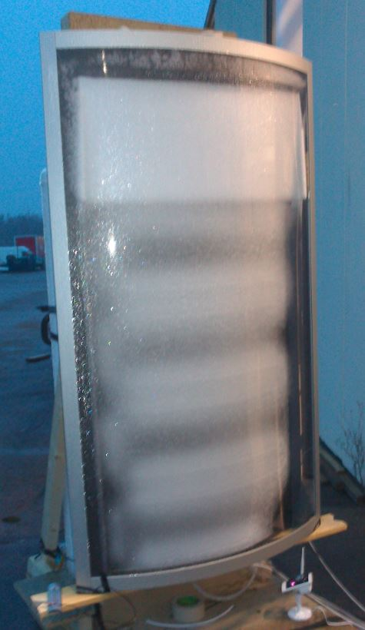
Figure 7. SoletAer post 12 hour test run.
- CONCLUSION

Performed tests indicate that SoletAer can run for long periods without defrosting and thereby reduce the energy spent on melting ice. Furthermore SoletAer can, in the right conditions, defrost by ventilation or by solar irradiation which will make it unnecessary to use the compressor for defrosting in many cases.

Further testing will be performed both in lab and in the form of pilot installations.

- REFERENCES

Commission, E. (2007). 2007/742/EC: Commission Decision of 9 November 2007 establishing the ecological criteria for the award of the Community eco-label to electrically driven, gas driven or gas absorption heat pumps. Brussels: European Commission.
Energimyndighet, S. (2012). Energistatistik för småhus 2012 (Energy statistics for one- and two-dwelling buildings 2012). Statens Energimyndighet.
European Commission. (2014, 03 03). Retrieved 03 05, 2014, from European Commission: http://ec.europa.eu/clima/policies/package/index_en.htm
Guo, X., Chen, Y., Wang, W., & Chen, C. (2008). Experimental study on frost growth and dynamic performance of air source heat pump system. Applied Thermal Engineering 28 , 2267-2278.
Kemna, R., van Elburg, M., Li, W., van Holsteijn, R., Denison-Pender, M., & Corso, A. (2007). Eco-design of water Heaters. Delft: VHK.
Swedish Energy Agency. (2013). Retrieved 03 05, 2014, from Swedish Energy Agency: https://www.energimyndigheten.se/Global/F%C3%B6retag/Ekodesign/Ekodesign/Pannor/06_Energy%20Labelling%20Water%20Heater-C%202013%20818.pdf
Swedish University of Agricultural Sciences. (2014, February 03). Retrieved 03 05, 2014, from Swedish University of Agricultural Sciences: http://www.ffe.slu.se/_db/wdbdata.cfm?WSTN=411
Xu, G., Zhang, X., & Deng, S. (2006). A simulation study on the operating performance of a solar-air source heat pump water heater. Applied Thermal Engineering , 1257-1265.

